DS 522 Data Acquisition and Analytics
HOS02A-2 – Python Functions and Files
06/30/2024 Developed by Catherine Ata
03/05/2025 Reviewed by Yogesh Goel
03/19/2024 Reviewed by Naveena Moddu
03/19/2026 Reviewed by Vishal Krishna Kumar

School of Technology & Computing (STC) @ City University of Seattle


Take Note Before Starting
• The directory path shown in screenshots may be different from your directory.
• Not all steps are explained in the tutorial. If you are not sure what to do:
1. Consult the resources listed below.
2. If you cannot solve the problem after several tries, email your course TA for help.

Learning Outcomes
• Understand the types of Python functions
• Understand how to create Python’s user-defined functions
• Learn how to use these functions
• Learn how to create and access Python modules
• Understand and learn how to write, update, and access text files in Python

Resources
- McKinney. (2022). Python for Data Analysis (3rd edition).
- Python.org. (2024). Python documentation. https://docs.python.org/3/
- W3 Schools. (2024). Python Variables. https://www.w3schools.com/python/python_lists.asp

Getting Started
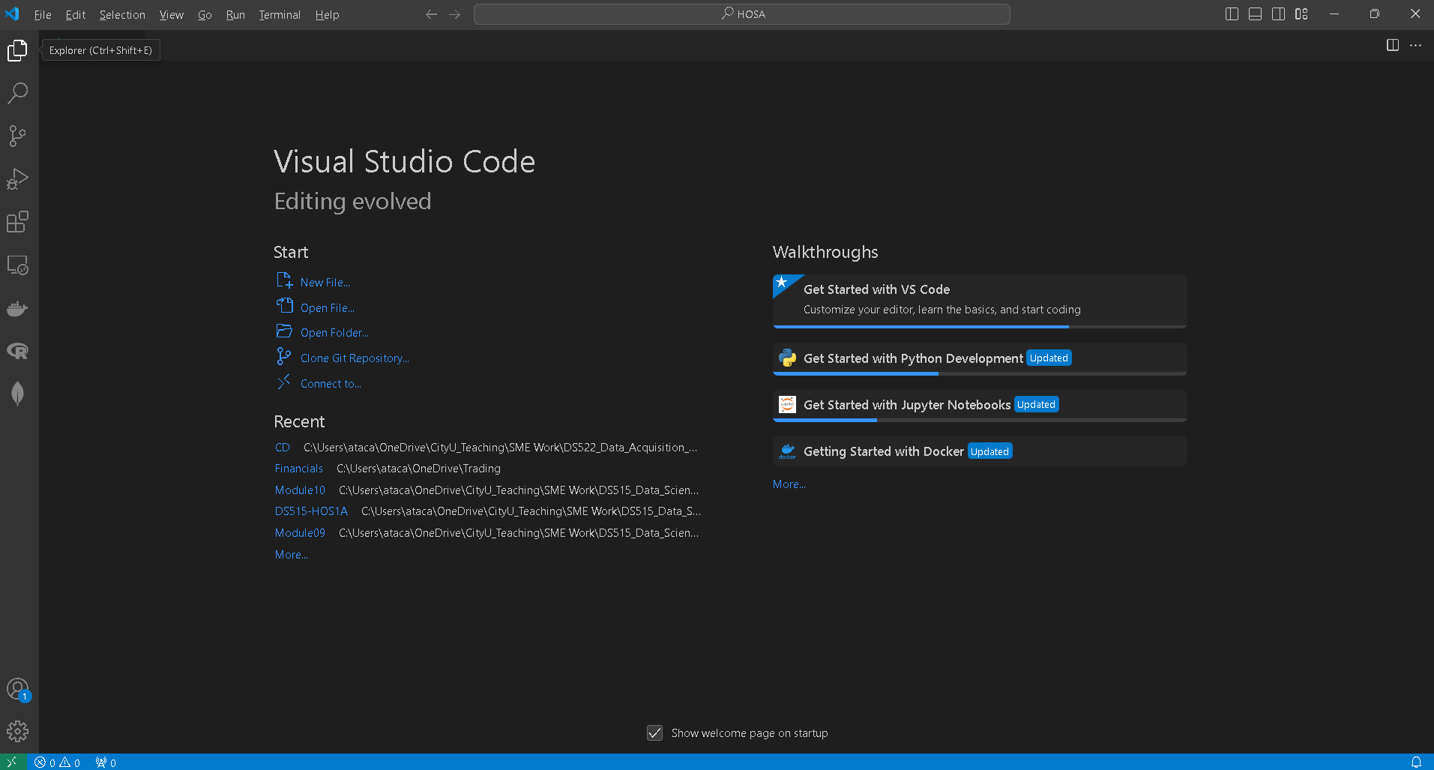
- Open the VS code and within the VS Code, open the DS522 course folder created earlier. On the menu tab, select File, then Open New Folder. Navigate to your work directory or GitHub repository that you have cloned. For example: C:\Users\my_workspace\Desktop\DS522
OR C:\Users\my_workspace\Desktop\DS522\github_repository_name
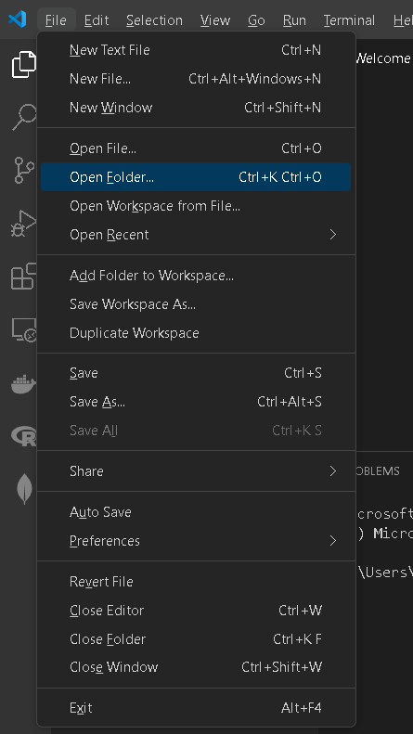
NOTE: If you have cloned a GitHub repository that is provided specifically for this course, navigate to that directory, and skip steps 2 to 4. This will be the folder where you will be storing all your HOS02A work.
- Once in your work directory, go to the menu tab again, select Terminal, select New Terminal to open a Command Line Interface (CLI) like the Command Prompt or PowerShell for Windows OS.
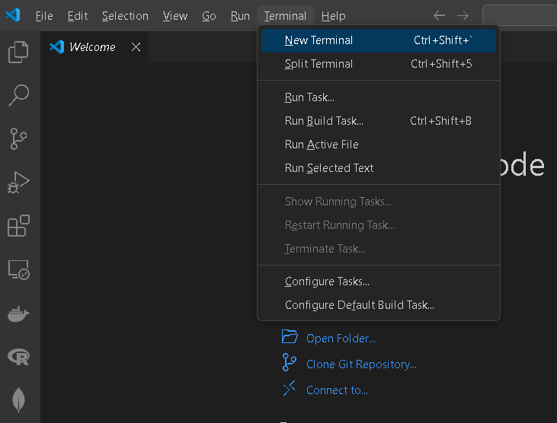

- Inside your “DS522” directory, create a new directory and name it “Module02”. Use the following command: (SKIP IF YOU HAVE ALREADY CREATED Module02 folder.)
>mkdir Module02
- Move to the new directory. Use the following command:
>cd Module02
NOTE: This will be the folder where you will be storing all your HOS02A work.

Python Functions and Files

Functions
A Python function is a structured and reusable piece of code designed to conduct a specific task. Functions enhance the modularity of your application and promote code reuse.

When developing processing logic, a top-down approach involves creating independent, reusable functions. We can call a Python function from another function by providing the necessary data (known as parameters or arguments). The function then returns its result to the calling environment.

Syntax:

def function_name(parameters):
“function docstrings”
code
return [expression]

The return [expression] statement exits a function, optionally passing back an expression to the caller. A return statement with no arguments is the same as return None.

Python provides the following types of functions:
a. Built-in functions
Python's standard library includes a number of built-in functions: print(), int(), len(), sum(), etc. These functions are always available, as they are loaded into the computer’s memory as soon as you start Python interpreter.

b. Functions defined in built-in modules
The standard library also bundles a number of modules. Each module defines a group of functions. These functions are not readily available, and you need to import them into the memory from their respective modules. Example: import pandas

c. User-defined functions
In addition to the built-in functions and functions in the built-in modules, you can also create your own functions. These functions are known as user-defined functions.

In this exercise, we will be focusing on creating user-defined functions.

1. Let us begin by creating a simple function to print texts. Create a file named functions.py and type the following code:

Run your script or type the following in the terminal to check the output of the above code: >>> python3 functions.py or >>>python functions.py

“print_text” is a user defined function, and it prints the string or text that is passed to it. There are two different strings that are being passed to the function in separate calls.
The return statement has no arguments and is the same as return None.

Return values
A function does not always have to display its output directly. Instead, it can process some data and then return a value or set of values. The value the function returns is known as a return value. The return statement takes a value from inside a function and sends it back to the line that called the function. Return values allow you to move much of your program's grunt work into functions, which can simplify the body of your program.

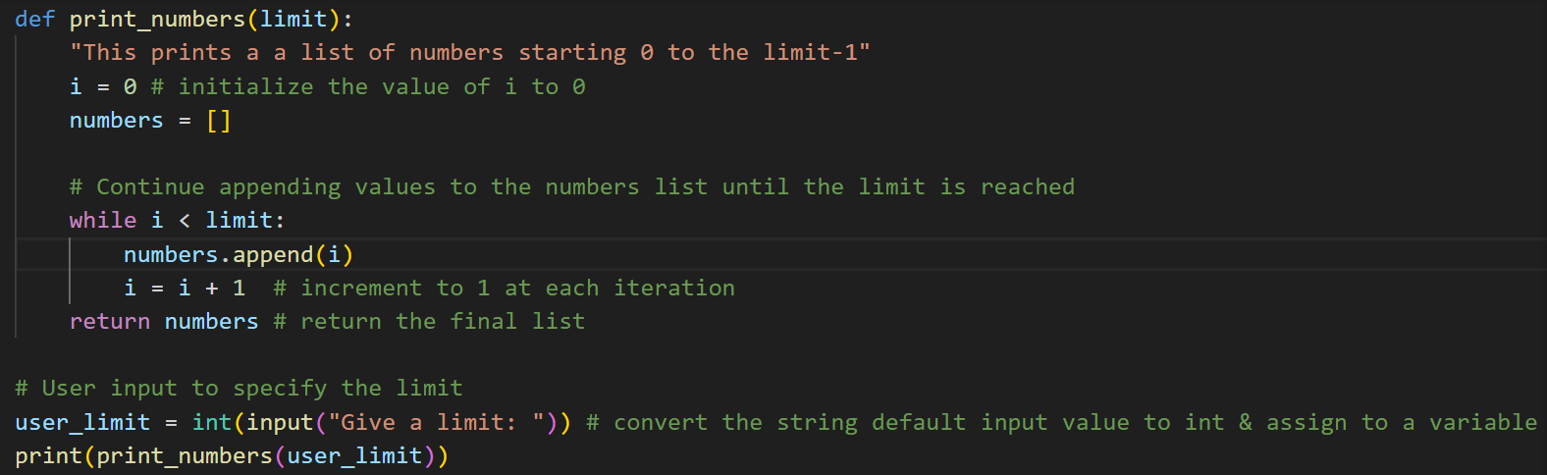
1. In your functions.py and type the following code, then run to see the output:
Output:

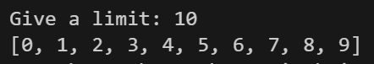

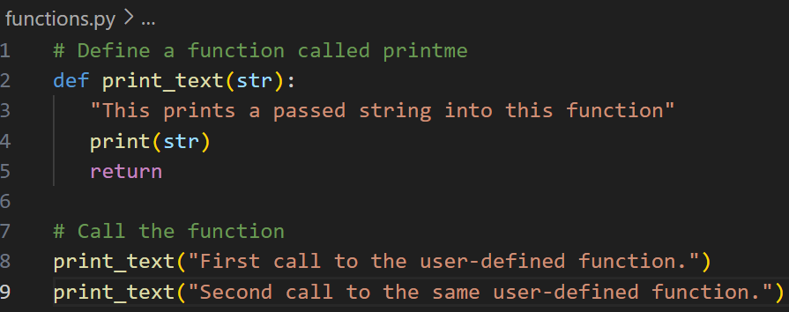
Function Arguments
These are the values or variables given to a function when it is invoked. The operation of a function frequently relies on the arguments it receives.

When defining a function, you specify variables, called formal parameters or parameters, within the parentheses. These parameters serve as placeholders for the data that will be provided to the function upon invocation. When the function is called, values for each of the formal parameters must be supplied, and these values are known as actual arguments.

Because a function definition can have multiple parameters, a function call may need multiple arguments. You can pass arguments to your functions in several ways.

- Positional Arguments: need to be in the same order as the parameters are written.
- Keyword Arguments: each argument consists of a variable name and a value.
- Arbitrary Number of Arguments: Sometimes you would not know the number of arguments a function needs. In that case, arbitrary arguments are used.

Positional Arguments
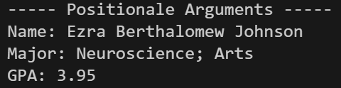
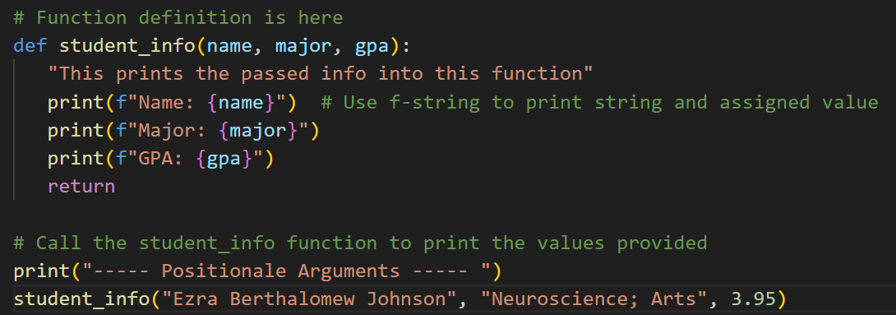
1. Create a file named arguments.py and type the following code:

Run and check the output:

In this example, when calling the student_info() function we need to provide three (3) arguments, one for the name parameter, another for the major parameter, and the other for the gpa parameter. If there is a missing argument, this will raise a TypeError missing one required positional argument. Additionally, the order matters in positional arguments; they should be in the same order as how the parameters are specified in the function definition. Otherwise, although there will be no errors when running the code, the result might not be as expected.

Keyword Arguments
2. In the same script type the following code and run to see the output:

Output:
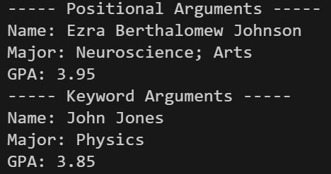

When passing keyword arguments, you need to have a name-value or parameter-argument pair, since you are directly associating the parameter name to the argument value, there will be no confusion, and you will get the expected result. This also allows you to pass the arguments in any order when calling the function.

We can also pass a default value to a parameter when defining a function in case there is no argument value provided when calling a function.

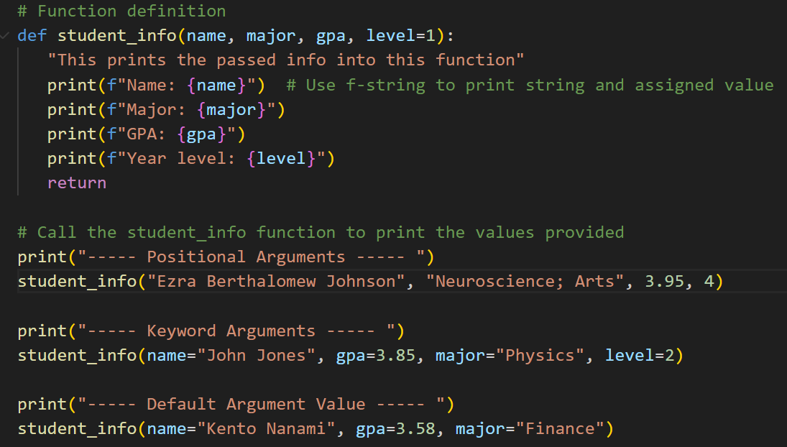
3. Edit the code in your arguments.py script and add the codes below; take note that we are adding the parameter “level = 1”. Run and check the output:

Output:
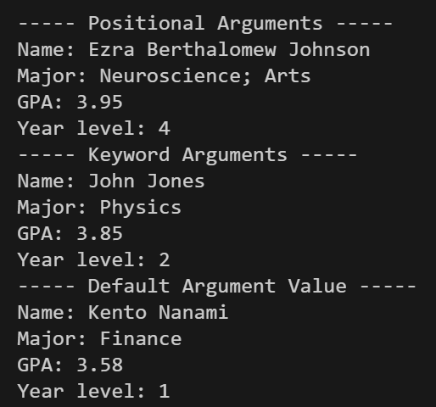

In this edited version of the function student_info(), we added a parameter “level” with a default value 1. When we call the function the third time, we explicitly tell Python which argument if for each parameter, and unlike the first two examples, we exclude the level parameter. In this case, we passed the “level” parameter with a default value.

Arbitrary Number of Arguments
Online shopping is commonly practiced nowadays. Online stores do not randomly add items to your list, and they certainly do not want your cart to be always empty. Considering this example and where the store has a large variety of products. Let us create a simple function that takes an arbitrary number of items and stores it in the cart.

1. Create a file named arbitrary.py and type the following: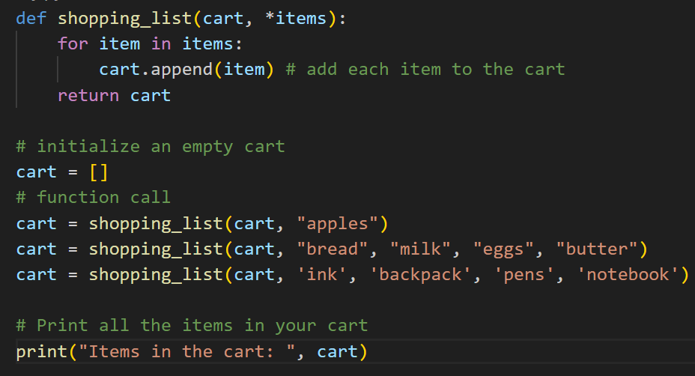
Output:

The asterisk in the parameter name *items tell Python to make an empty tuple called “items” and pack whatever values it receives into this tuple. Python packs the arguments into a tuple, even if the function receives only one value. The for loop will iterate through all the elements in the items tuple and add each to the empty cart list which is initialized outside the function. This will store all the items provided each time the function shopping_list is called. The asterisk before the function parameter allows Python to manage a function call with one value and a call with four values or more. It treats the different calls similarly.

Storing Functions in Modules and Importing Modules
You can store the functions in a separate file called a module and then import that module into your main program. An import statement tells Python to make the code in a module available in the currently running program file.

1. Create a file named shopping_module.py and type the following code:
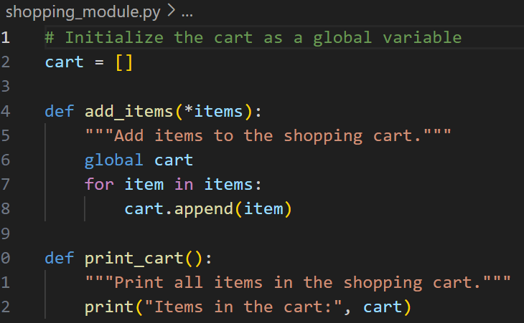
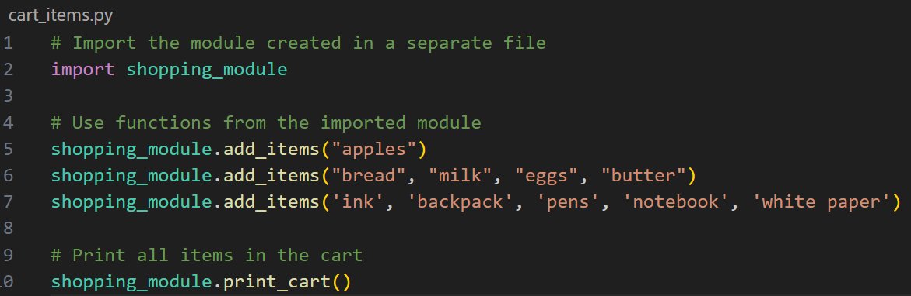
2. Create another file named cart_items.py and type the following code:

3. Type the following in the terminal to check the output of the above code:
>>> python cart_items.py

Output:

In this online shopping example, the main file is cart_items.py where we are importing another
file called shopping_module.py. This means the import tells Python to open the file shopping_module.py and copy all the functions from it into this program.

Files
Files can be a persistent way to store your data even though your program has finished. Also, you can check whether your files or flash drives exist or are connected to the computer.

Basic steps to reading or writing to a file in Python:
• Call the open () function to return a File object.
• Call the read() or write() method on the File object.
• Close the file by calling the close() method on the File object.

1. Create a text file named hello.txt and type “Hello! Welcome to the DS522 course.”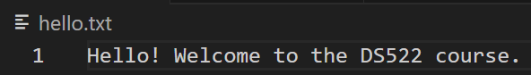

2. Create a file named files.py and type the following code. Run the code, you will see the output is identical as the string inside the hello.txt file.
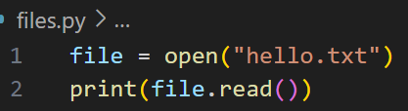

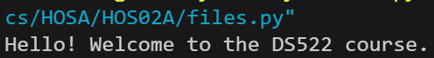
Output:

3. Create another file named files2.py and type the following code. Run and compare the output from the previous code.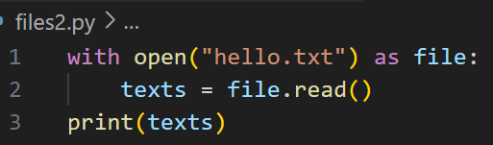

Output:
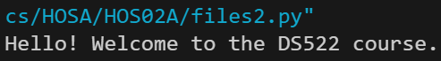

The second example is another and the preferred method for opening and reading a file.

The open() function needs one argument, which is the name of the file you want to open. Python looks for this file in the directory where the program that is currently executed is stored. In this example, “files2.py” is currently running, so Python looks for “hello.txt” in the directory where “files2.py” is stored. The open() function returns an object representing the file. Here, open(‘hello.txt’) returns an object representing “hello.txt.” Python assigns this object to the” file” object.

The with keyword closes the file once it is no longer needed. Notice how we call open() in this program but not close(). You could open and close the file by calling open() and close(), but if a bug in your program prevents the close() method from being executed, the file may never close.

There is a slight difference between the output from running the file and the original file is the extra blank line at the end of the output. The blank line appears because read() returns an empty string when it reaches the end of the file; this empty string shows up as a blank line. If you want to remove the extra blank line, you can use rstrip() in the call to print(), like this:

Append & Write mode
1. Create a file named file_mode.py and type the following code: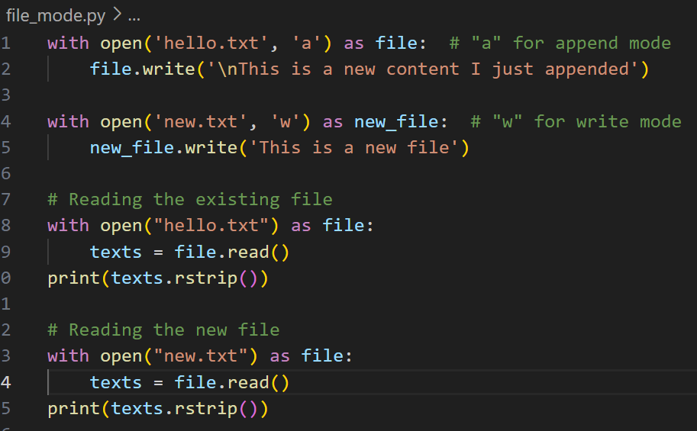
Output :

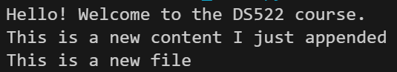

In this example, we use “a” for append mode because the content already exists. Using “w” for write
mode will overwrite the existing file with new values. Both append and write mode will create a new file if it does not exist.

After running the file_mode.py, you will get a new text file called new.txt with new contents and the hello.txt file will have updated contents.

Making a list of lines of strings from a file
1. Create a file named files_list.py and type the following code:
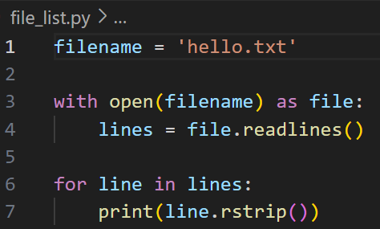
Output

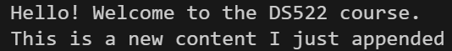

When you use with, the file object returned by open() is only available inside the with block that contains it. If you want to retain access to a file's contents outside the” with” block, you can store the file's lines in a list inside the block and then work with that list, i.e., the variable “lines” in this example.

The readlines() method takes each line from the file and stores it in a list. This list is then assigned to the lines variable, which we can continue to work with after the with block ends, as seen in the for loop.

Exceptions
An exception is an event which occurs during the execution of a program that disrupts the normal flow of the program's instructions. In general, when a Python script encounters a situation that it cannot manage, it raises an exception. An exception is a Python object that represents an error. When a Python script raises an exception, it must either manage the exception immediately otherwise it terminates the program.

Syntax try:
You do your operations here. ......................
except ExceptionI:
If there is ExceptionI, then execute this block. except ExceptionII:
If there is ExceptionII, then execute this block. ......................
else:
If there is no exception, then execute this block.

A single try statement can have multiple except statements. This is useful when the try block contains statements that may throw several types of exceptions.

1. Create a file named exception_handling_1.py and type the following code:

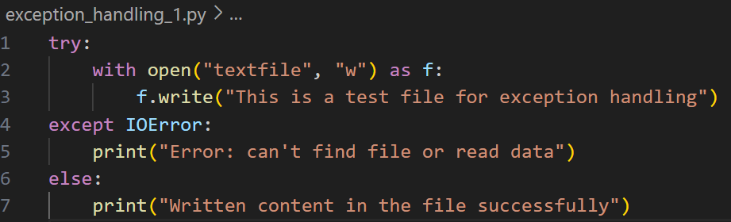
Run and check the output:

In this example, Python opens the file, writes content in the file, and comes out gracefully because there is no problem at all.

2. Create a file named exception_handling_2.py and type the following code: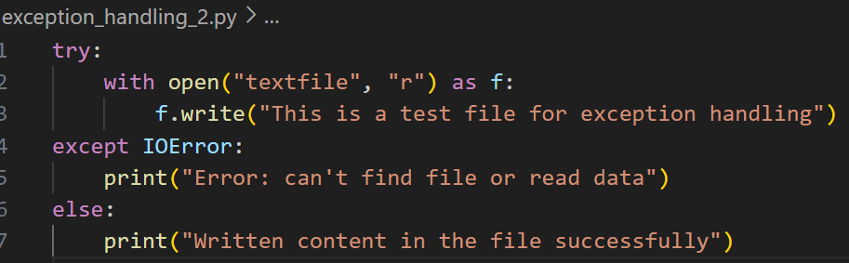

Run and check the output:

In this example, Python tries to open a file with no writing permission, so it raises an IOError.

try-finally Clause
The finally block is a place to put any code that must execute, whether the try-block raised an exception or not.

Syntax try:
You do your operations here. ......................
Due to any exception, this will be skipped. finally:
This will always be executed. ......................

3. Create a file named exception_handling_3.py and type the following code:
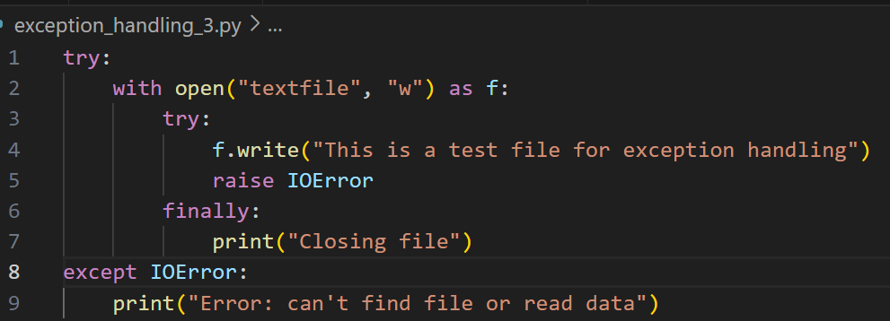
Run and check the output:

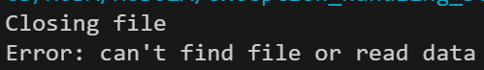

In the above code, access to write in the “textfile” is satisfied. So, the statement mentioned is written to the “textfile.”

For demo purposes, an IOError is raised in the try bock even though an IOError did not occur.

An exception is thrown in the try block, so the execution immediately passes to the finally block. After all the statements in the finally block are executed, the exception is raised again and is handled in the except statements if present in the next higher layer of the try-except statement.

Push your work to GitHub.
Follow the instructions on the CityU STC TA Center Github.io Submit your work page

You may also follow the instructions below:
1. Open the cmd terminal for Windows users,
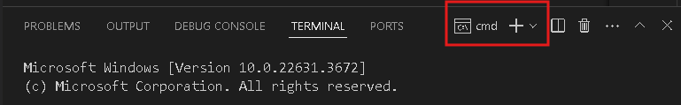

2. After selecting the + button, make sure the terminal is cmd if you have not closed the Python terminal.

If the terminal is not cmd, then you need to add it by opening the drop-down box, choose the Select Default Profile.
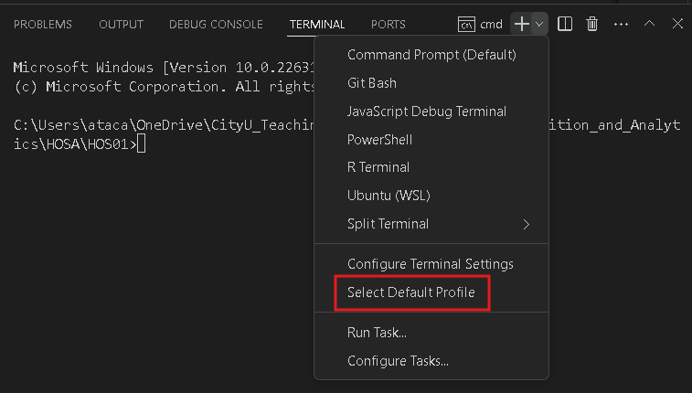

Look for and then select Command Prompt.
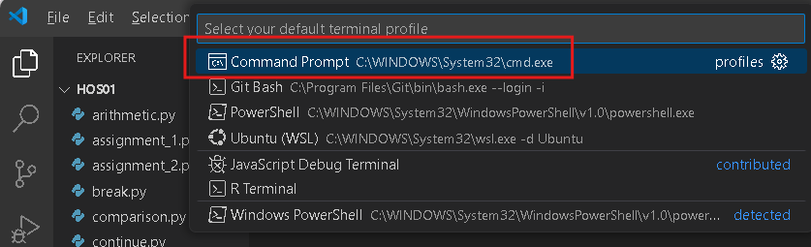

Click the + button. The command prompt will open.
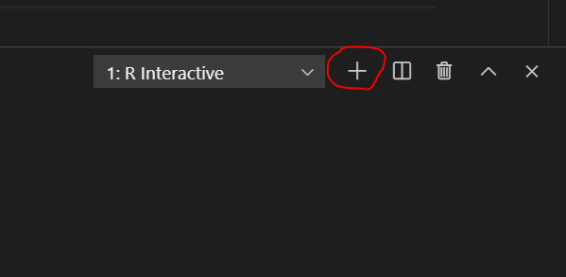



3. Make sure you are in the correct directory/repository: Desktop/DS522/hos02a-courseName-yourUserName

Run the following commands to push your work to the GitHub repository:
Open the terminal from the VSCode by hitting the control + ~ key and type the following command:
>>> git add .
>>> git commit -m “Submission for HOS02A- Functions and Files”
>>> git push

*** Please answer HOS02B in Brightspace. ***

